Transform Pre-coding

# The Time elapsed for 14400 symbols which is the max symbols can be transmitted in the max Resource Blocks for one UE 100 RBs

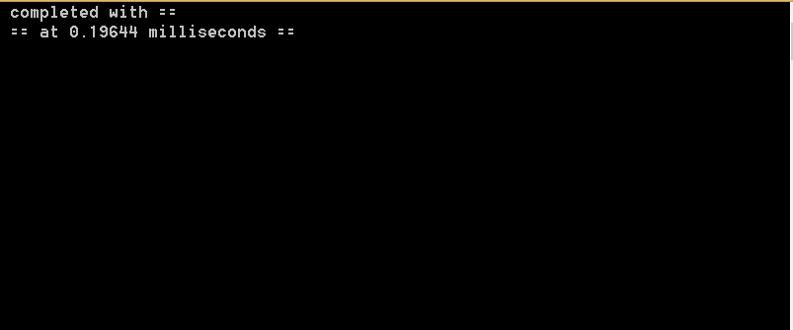

Figure 1: Time taken in the Transform Pre-coding

# The previous results are the average result from 20 trials.

# We are using 1D FFT as both 2D and 3D FFT aren’t suitable for our case.